**Evaluating Blockchain APIs:**

**Objective:**

1. Review the API documentation of each blockchain network to understand authentication methods and data retrieval mechanisms.
2. Identify any API keys or authentication tokens required for accessing blockchain data.

**Blockchain APIs:**

1. Bitquery - <https://bitquery.io/>
2. CoinBase API
3. Binance API
4. The Graph - <https://thegraph.com/>
5. Covalent - <https://www.covalenthq.com/>
6. Quicknode - <https://www.quicknode.com/>
7. Moralis - <https://moralis.io/>

**QUICK Explanation of how Data is stored on the Blockchain:**

1. **Storage system breaks data into shards. (Divide the Data into small pieces of Data – This allows the data to be disturbed easier and more efficiently across the nodes).**
2. **Then Each Shard is Cryptographically encrypted on each of your local system so only you the owner can view it.**
3. **Now the Blockchain Storage system creates a hash that is assigned to each Shard.**
4. **Then the Hash is added to both the Ledger (The Blockchain) and the Metadata (Description about the ‘Block in the Blockchain’) to link transactions to the stored shards.**
5. **Storage system copies this data multiple times (Prevent data loss) and then the replicated Shards are sent to geographically dispersed storage nodes owned by individuals called ‘farmers’ (Data is still only accessible to the owners).**
6. **Storage System records all the transaction details like shard hash, shard location in the Blockchain ledger and syncs that information across all nodes**

**(Research about blockchain Storage systems)**

**Blockchain API tables:**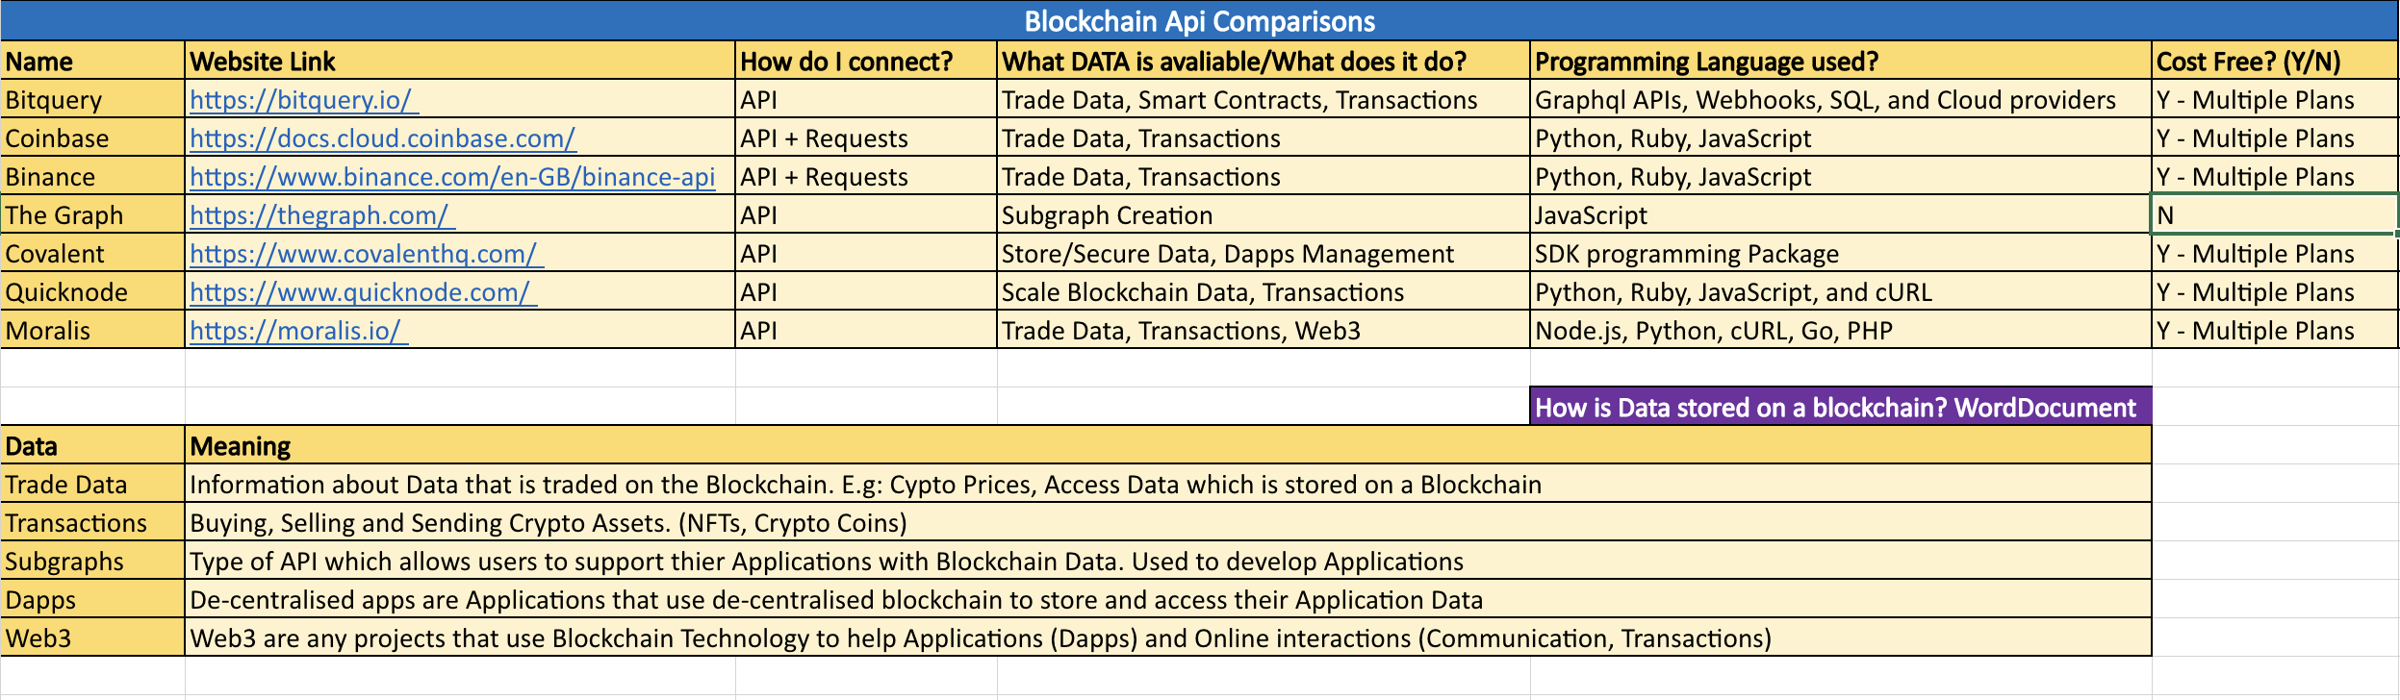

**Why I chose to use Moralis:**

Moralis - <https://moralis.io/>

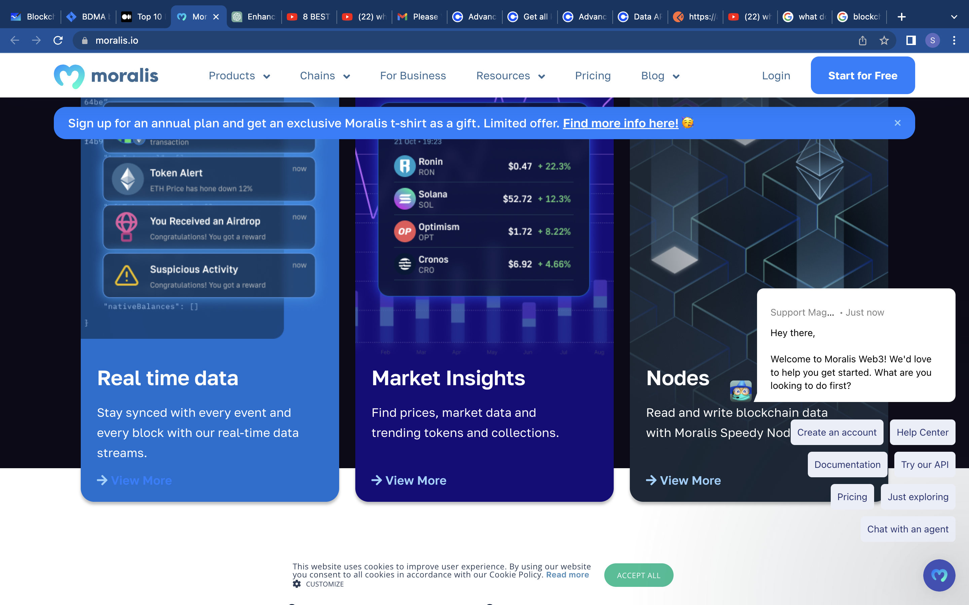

The reason I chose Moralis was the fact that not only does it have in depth accessibly to Market Data of Crypto currencies but also has a wide range of other possible APIs such as: Blockchain Data API, Receive Real-time Block data and Transaction data API are just the few to mention. Therefore, this is a great starting point which in the future if I want to expand my knowledge into these sectors/areas the language will already be native to me.